**General Test Method for Temperature Testing**

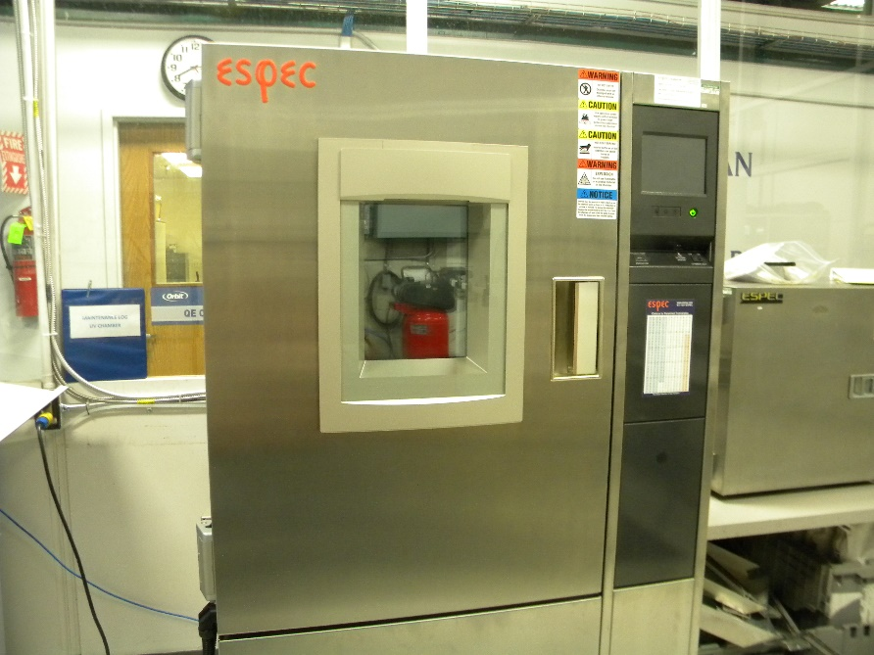

CONTENTS

1 Equipment 3

1.1 Water Test Tank 3

1.2 Temperature Chamber 3

2 Software 3

3 Setup 3

3.1 Water Test Tank Setup: 3

3.2 Temperature Chamber Setup 3

4 General Test Procedure 4

4.1 General Temperature Testing 4

5 Temperature Profile Definitions 4

5.1 24FREZTHW 4

5.2 48FREZTHW 5

5.3 TCYC96HR 5

5.4 48STORAGE 5

5.5 BLUTHERM 6

6 Data Format and Reporting 6

6.1 Section 4.1 6

1. Equipment

The Following Equipment is required for this testing:

* 1. Water Test Tank
     1. Calibrated Pressure Gauge
        1. The pressure gauge must be calibrated and have a minimum pressure capability of 175 psi.
     2. Water Test Tank
        1. Test tank must be capable of changing pressure, which includes valves, pumps, and piping. The pump should be capable of supplying water at a minimum flow rate of 45 GPM at 150 psi.
  2. Temperature Chamber

Temperature chamber must have the ability to change temperature from -4°F to 140°F.

1. Software

None Required

1. Setup
   1. Water Test Tank Setup:

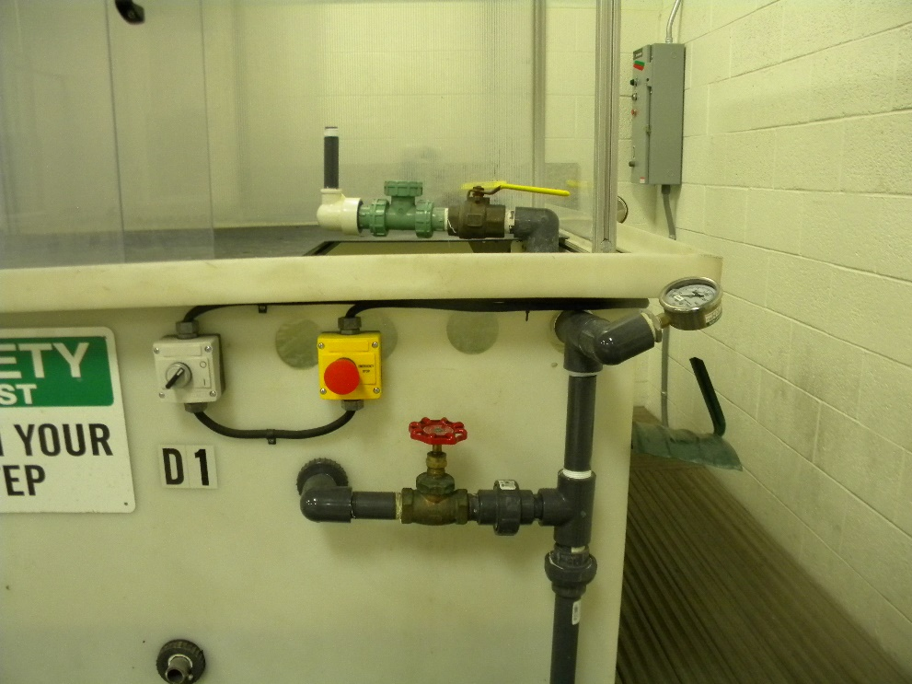

* + 1. Parts Needed: water pump, tank, pressure control valve, pressure gauge, properly sized riser, piping, and adapters.
  1. Temperature Chamber Setup



* + 1. Parts Needed: temperature chamber.

1. General Test Procedure
   1. General Temperature Testing
      1. Perform a working pressure test [GTM-005] to ensure full functionality of the product before the temperature test.
      2. Place the product into the temperature chamber *(Fig 1)*.

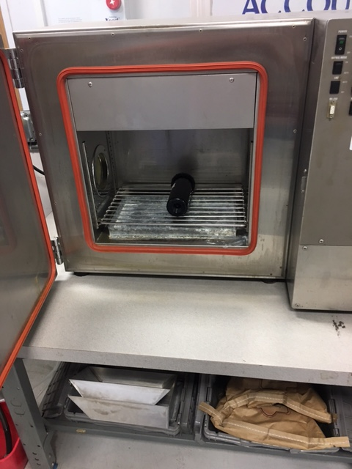

*Figure 1: Product in the temperature chamber.*

* + 1. Set the chamber to the desired temperature profile.
    2. Once the profile has completed, remove the product and perform a working pressure test [GTM-005] to ensure full functionality after the temperature test.

1. Temperature Profile Definitions

*Note: “Ramp” means have the temperature go to the desired temperature. “Soak” means hold the temperature for the specified amount of time.*

* 1. 24FREZTHW
     1. Summary
        1. Total Cycles: 3
        2. Minimum Temperature (°F): 33
        3. Maximum Temperature (°F): 120
        4. Runtime (hours): 24
     2. Programming Procedure
        1. Ramp to set temperature 33°F for 30 minutes.
        2. Soak at 33°F for 3 hours 30 minutes.
        3. Ramp to set temperature 120°F for 30 minutes.
        4. Soak at 120°F for 3 hours 30 minutes.
        5. Repeat steps 5.1.2.1 to 5.1.2.4 three times.
        6. Ramp to ambient temperature 75°F.
        7. Shut off
  2. 48FREZTHW
     1. Summary
        1. Total Cycles: 3
        2. Minimum Temperature (°F): 33
        3. Maximum Temperature (°F): 120
        4. Runtime (hours): 48
     2. Programming Procedure
        1. Ramp to set temperature 33°F for 1 hour.
        2. Soak at 33°F for 7 hours.
        3. Ramp to set temperature 120°F for 1 hour.
        4. Soak at 120°F for 7 hours
        5. Repeat steps 5.2.2.1 to 5.2.2.4 three times.
        6. Ramp to ambient temperature 75°F.
        7. Shut off
  3. TCYC96HR
     1. Summary
        1. Total Cycles: 16
        2. Minimum Temperature (°F): 33
        3. Maximum Temperature (°F): 140
        4. Runtime (hours): 96
     2. Programming Procedure
        1. Ramp to set temperature 33°F for 1 hour.
        2. Soak at 33°F for 3 hours.
        3. Ramp to set temperature 140°F for 1 hour.
        4. Soak at 140°F for 1 hours.
        5. Repeat steps 5.3.2.1 to 5.3.2.4 15 times.
        6. Ramp to ambient temperature 75°F.
        7. Shut off
  4. 48STORAGE
     1. Summary
        1. Total Cycles: 1
        2. Minimum Temperature (°F): 0
        3. Maximum Temperature (°F): 140
        4. Runtime (hours): 48
     2. Programming Procedure
        1. Ramp to set temperature 0°F for 30 minutes.
        2. Soak at 0°F for 23 hours 30 minutes.
        3. Ramp to set temperature 140°F for 30 minutes.
        4. Soak at 140°F for 23 hours 30 minutes.
        5. Ramp to ambient temperature 75°F
        6. Shut off
  5. BLUTHERM

*NOTE: This is an accelerated 30 year freeze/thaw cycle.*

* + 1. Summary
       1. Total Cycles: 11
       2. Minimum Temperature (°F): -4
       3. Maximum Temperature (°F): 104
       4. Runtime (hours): 264
    2. Programming Procedure
       1. Ramp to set temperature 104°F for 1 hour.
       2. Soak at 104°F for 3 hours.
       3. Ramp to set temperature 68°F for 1 hour.
       4. Soak at 68°F for 2 hours.
       5. Ramp to set temperature -4°F for 1 hour.
       6. Soak at -4°F for 2 hours.
       7. Ramp to set temperature 68°F for 1hour.
       8. Soak at 68°F for 2 hours.
       9. Ramp to set temperature 104°F for 1 hour.
       10. Soak at 104°F for 2 hours.
       11. Ramp to set temperature 68°F for 1 hour.
       12. Soak at 68°F for 2 hours.
       13. Ramp to set temperature -4°F for 1 hour.
       14. Soak at -4°F for 2 hours.
       15. Ramp to 68°F for 1 hour.
       16. Soak at 68°F for 1 hour.
       17. Repeat steps 5.5.2.1 to 5.5.2.16 10 times.
       18. Ramp to ambient temperature 75°F.
       19. Shut off

1. Data Format and Reporting
   1. Section 4.1
      1. Any observations after temperature testing.

* END *